Project :Personal Finance Advisor Bot
Project Description:
The Personal Finance Advisor Bot is an AI-powered financial planning assistant designed to help individuals manage their personal finances efficiently and make informed financial decisions. The system enables users to record their monthly income, track daily and weekly expenses, categorize expenditures, generate personalized budgets, and monitor their savings progress through a centralized digital platform.
The application analyzes users' income and spending patterns to identify overspending, provide intelligent financial insights, and suggest suitable budgeting and saving strategies. It also generates monthly financial reports that summarize total income, expenses, and savings, helping users understand their financial position.
The system is developed using Flask for backend development, SQLAlchemy for database management, and AI-driven financial analysis for personalized recommendations. Its primary objective is to reduce manual financial record-keeping, improve financial awareness, encourage disciplined spending habits, and simplify personal financial management.

Scenarios
Scenario 1: A salaried professional logs monthly income and daily expenses across categories such as rent, food, transport, and entertainment. The system analyzes the spending data, identifies overspending areas, and generates a personalized budget plan with actionable saving suggestions. The user receives a monthly summary report showing income vs. expenses, savings achieved, and financial goals for the following month.

Scenario 2: A college student uses the Personal Finance Advisor Bot to manage a limited monthly allowance across essential and discretionary spending categories. The platform helps the student set realistic budget limits, track spending habits, and receive AI-powered recommendations for reducing unnecessary expenditures. This enables better financial discipline and improved savings management within a constrained budget.

Scenario 3: A freelancer with variable monthly income uses the platform to log earnings from multiple clients and track project-related expenses. The system adapts budget recommendations based on fluctuating income patterns, highlights months with reduced saving capacity, and suggests strategies for building an emergency fund. By maintaining structured financial tracking, the platform helps improve long-term money management and financial stability.

Scenario 4: A household manager uses the system to monitor shared family income and expenses across categories such as groceries, utilities, education, and healthcare. The bot generates a consolidated monthly financial report, identifies budget overruns in specific categories, and provides tailored saving strategies to meet family financial goals. This enables better household financial planning, resource allocation, and long-term savings improvement.

Technical Architecture

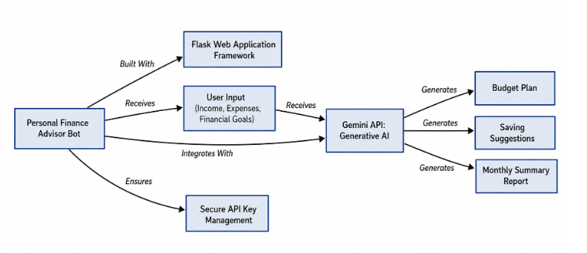
Description:
The Personal Finance Advisor Bot is designed using a web-based architecture that integrates user input, backend processing, Generative AI, and secure API key management to provide personalized financial assistance.
The system uses the Flask Web Application Framework to develop and manage the web application. Users enter their monthly income, expenses, and financial goals through the user interface. This information is processed and sent to the Gemini API, which uses Generative AI to analyze the user's financial data and generate personalized budget plans, saving suggestions, and monthly summary reports.
Secure API key management is implemented to protect API credentials and ensure secure communication with the AI service. The generated results are then displayed to users through the web application, helping them understand their spending patterns and manage their finances efficiently.
Project Workflow:
Personal Finance Advisor Bot
The project workflow describes the step-by-step development of the Personal Finance Advisor Bot, from requirement analysis to deployment. The project is divided into milestones to ensure systematic development, testing, and implementation.
1. Project Workflow
Milestone 1: Requirement Analysis
Identify user needs, project objectives, and functional requirements.
Milestone 2: System Design
Design system architecture, database structure, and user interface.

Milestone 3: Frontend Development
Develop dashboard, income and expense forms, and financial reports interface.

Milestone 4: Backend and Database Development
Implement Flask backend, SQLAlchemy database, and financial data management.

Milestone 5: AI Integration and Financial Analysis
Implement budget generation, spending analysis, and personalized financial suggestions.

Milestone 6: Testing and Deployment
Test functionality, fix errors, and deploy the application for public access.
Model Selection Approach:
The system uses the following models and processing approaches:
Financial Data Model: Stores user income, expense categories, transaction amounts, and savings information.
Budgeting Model: Calculates available income, planned expenditure, and savings using financial rules and recorded data.
AI Recommendation Model: Analyzes spending patterns and generates suggestions to help users control expenses and improve savings.
Reporting Model: Summarizes monthly financial transactions and presents income-versus-expense reports.
4.3 System Architecture
The system follows a layered full-stack architecture in which the frontend communicates with the Flask backend, which processes financial data and recorded data.
AI Recommendation Model: Analyzes spending patterns and generates suggestions to help users control expenses and improve savings.
Reporting Model: Summarizes monthly financial transactions and presents income-versus-expense reports.
4.3 System Architecture
The system follows a layered full-stack architecture in which the frontend communicates with the Flask backend, which processes financial data and interacts with the database and AI analysis component.
Presentation Layer
HTML • CSS • JavaScript
Dashboard, forms, charts, and chatbot interface
2. Application Layer
Python Flask
Routes, request handling, validation, and business logic
3A. Data Layer
SQLAlchemy + Database
Income, expenses, budgets, savings
3B. AI Analysis Layer
Financial Analysis Engine
Spending insights and recommendations
4. Output Layer
Budget plans • Savings insights • Monthly reports
Required Project Files:
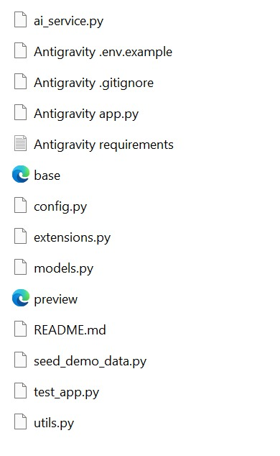
Backend Architecture Workflow:
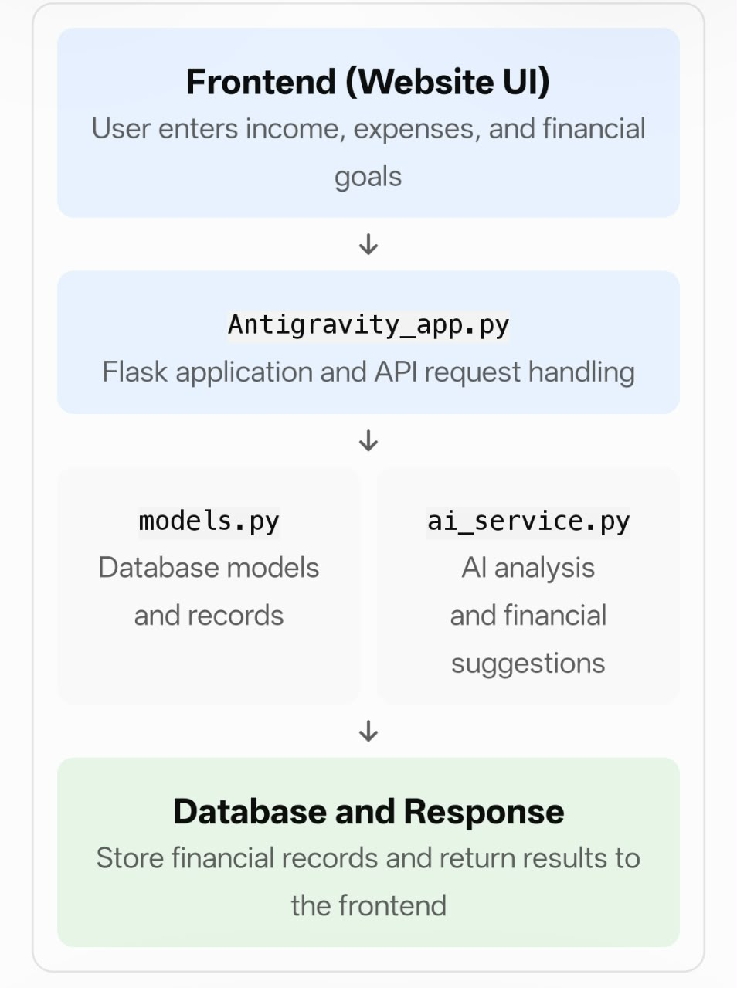
Backend Description
The backend of the Personal Finance Advisor Bot is designed using Python and the Flask framework. It manages user requests, processes financial information, and connects the frontend interface with the database and AI services. The backend consists of application configuration, database models, AI service modules, utility functions, and API handling components. SQLAlchemy is used for database interaction, while the AI service supports intelligent financial analysis, budget generation, and personalized saving recommendations. The backend also includes testing and demo-data utilities to support application testing and demonstration.

Result Section:
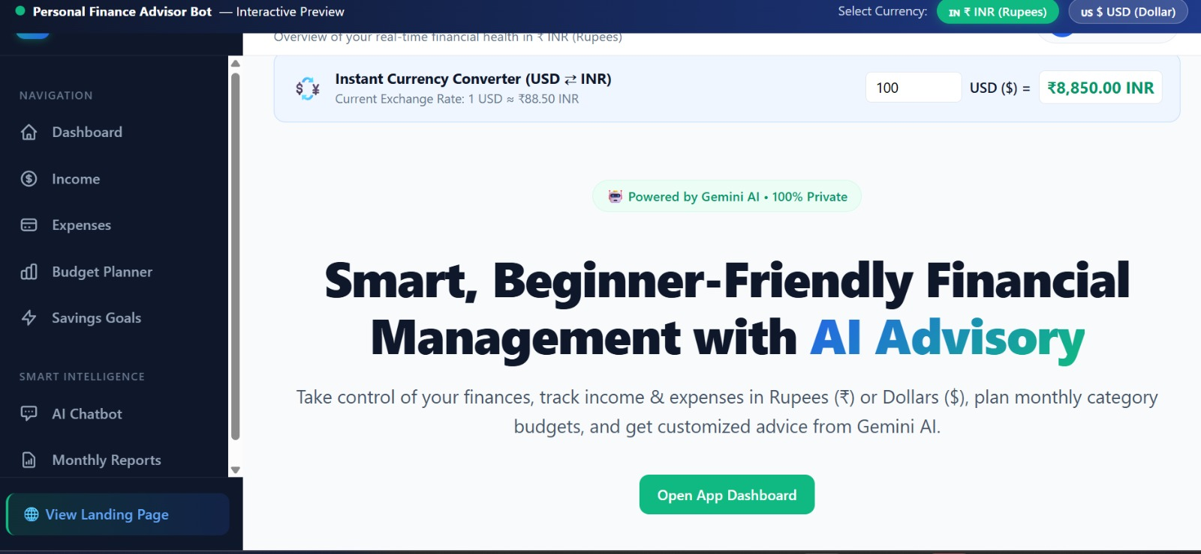
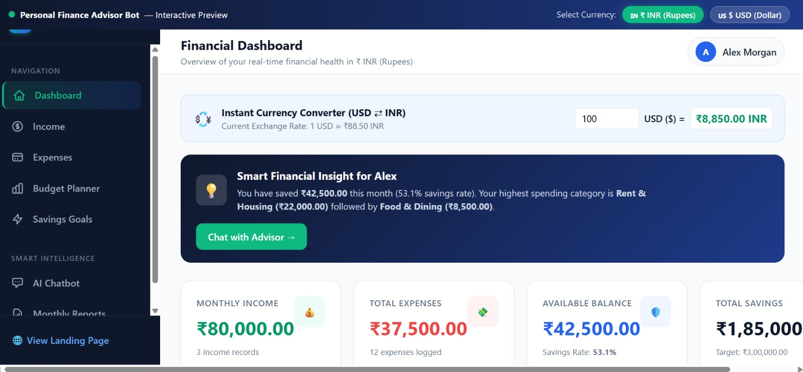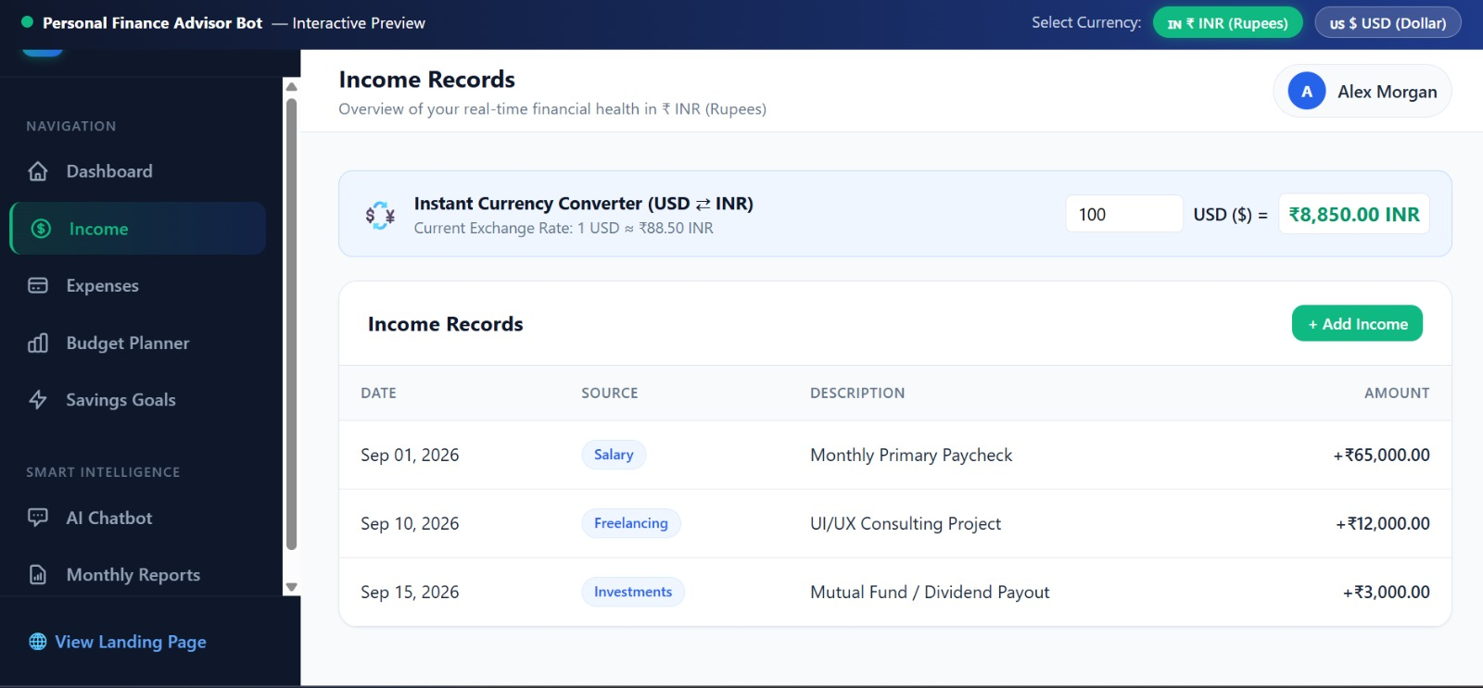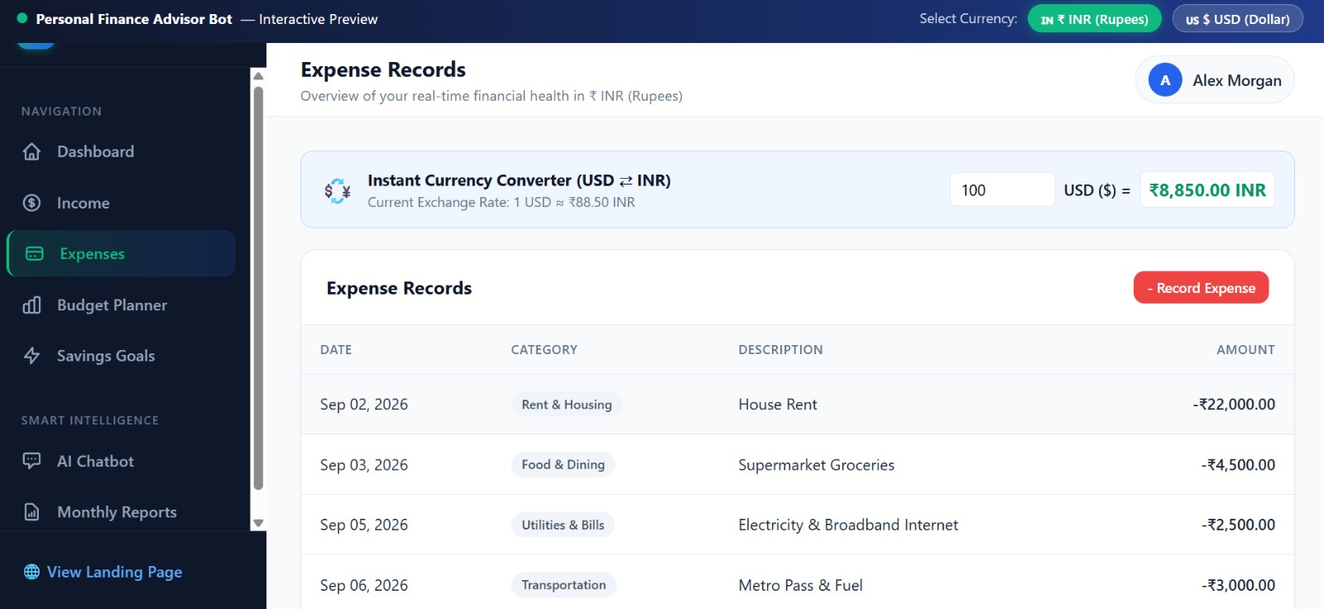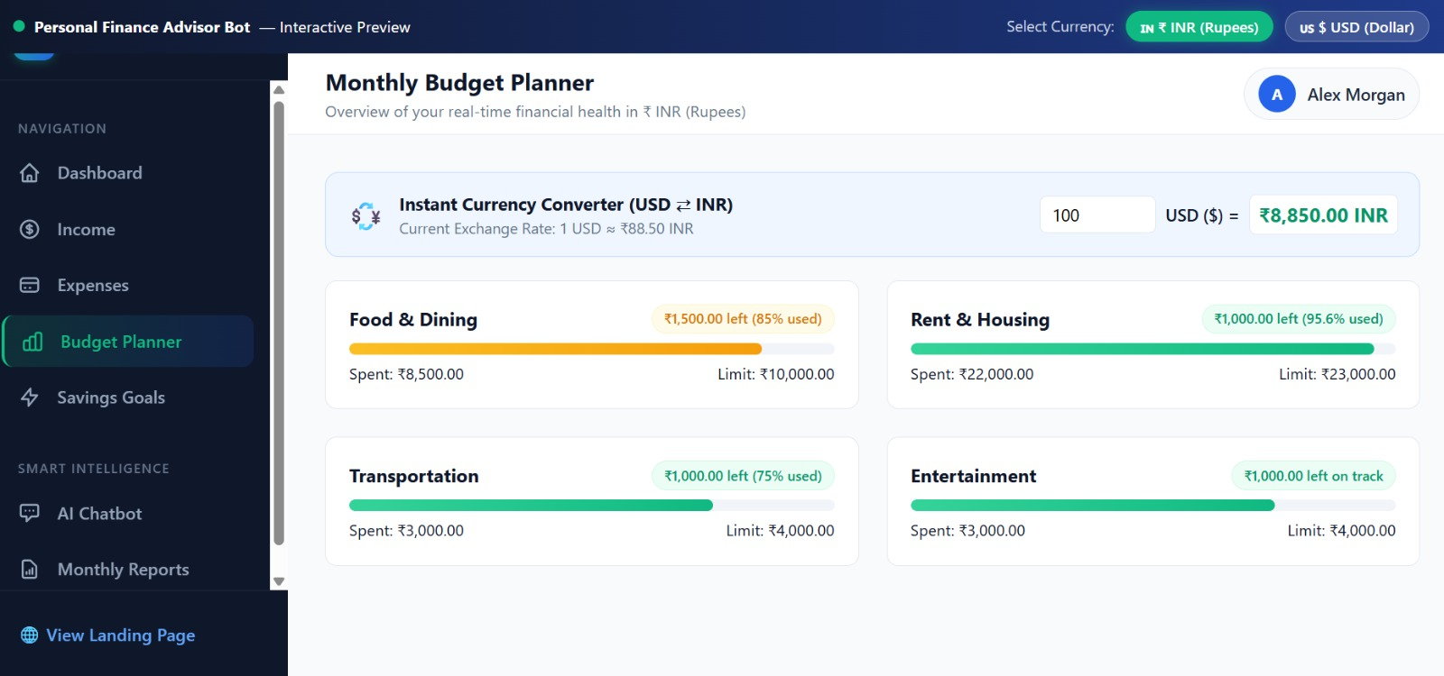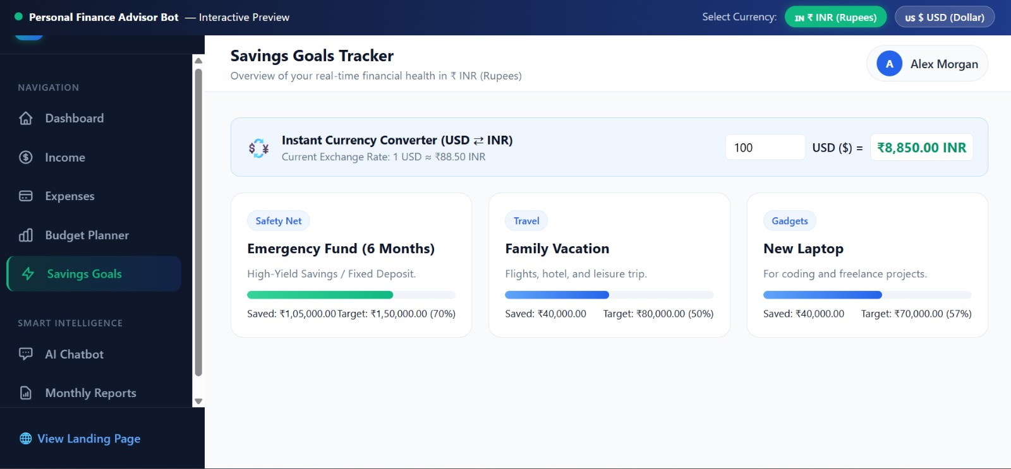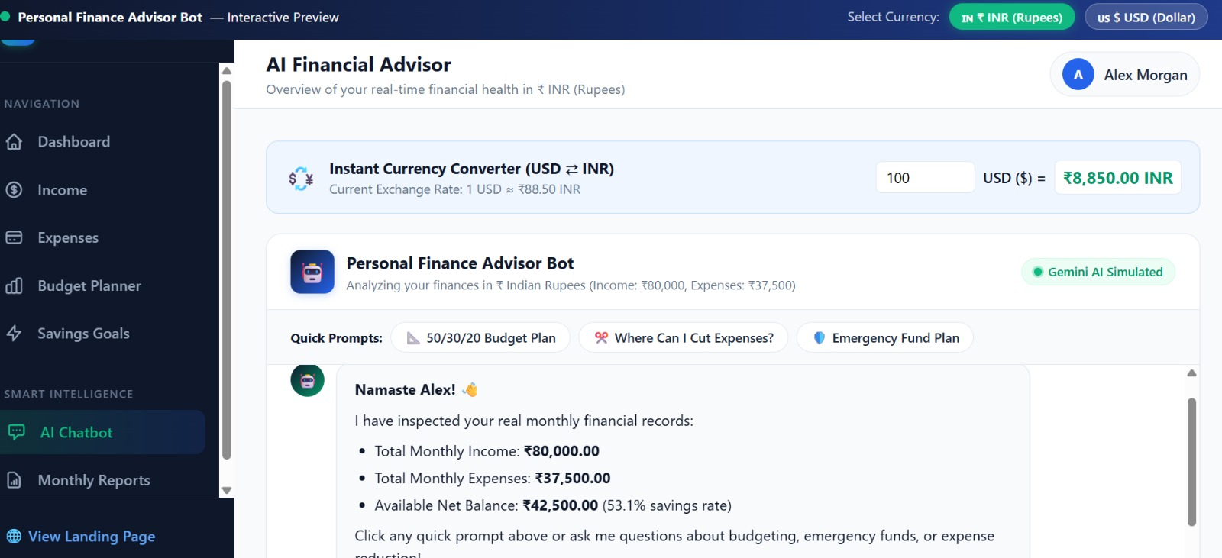
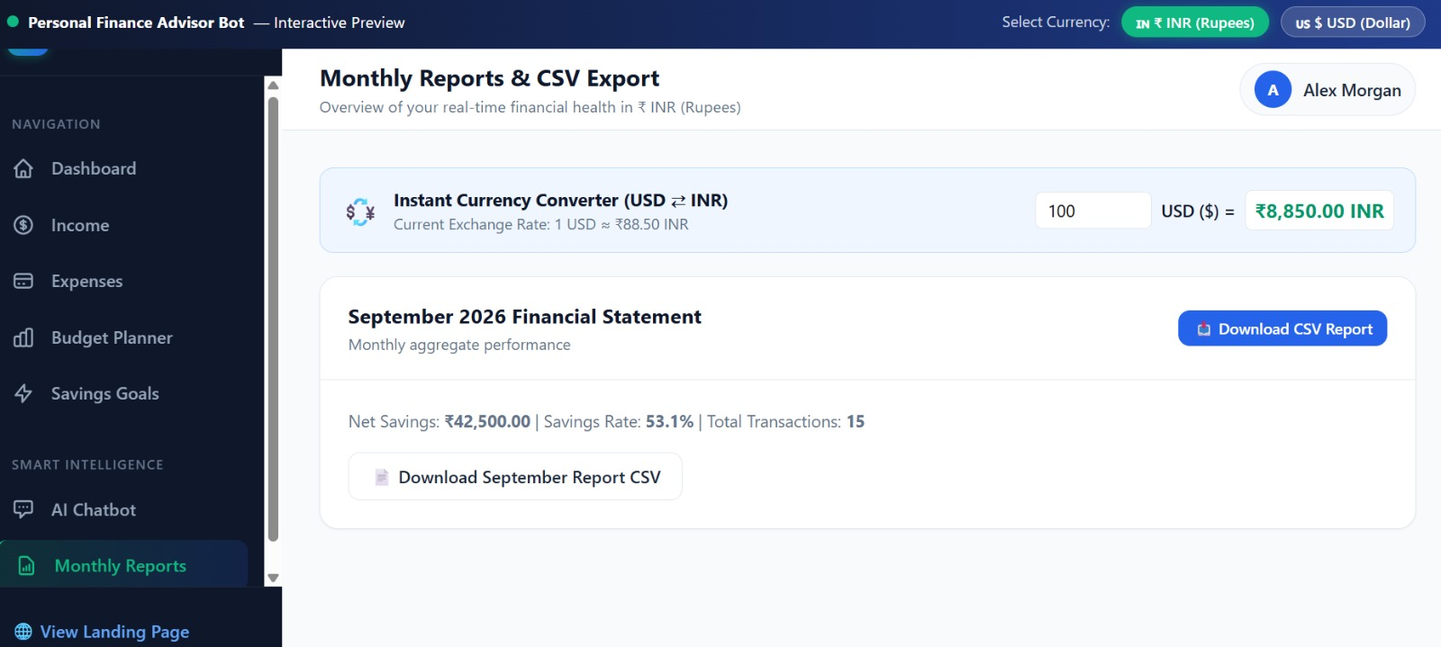
Conclusion – Personal Finance Advisor Bot
The Personal Finance Advisor Bot is an AI-powered financial management system designed to help individuals manage their income, expenses, budgets, and savings efficiently. It provides a centralized platform for recording financial transactions, monitoring spending patterns, setting savings goals, and generating monthly financial reports.
The system combines a user-friendly interface, backend technologies, database management, and AI-based financial insights to simplify personal financial planning. Features such as currency conversion, budget planning, and an AI chatbot support informed financial decisions and better financial awareness.
Overall, this project demonstrates how technology and artificial intelligence can make personal finance management more organized, accessible, and efficient. Future enhancements may include predictive expense analysis, goal-based financial planning, and advanced personalized recommendations.
Thank You!

